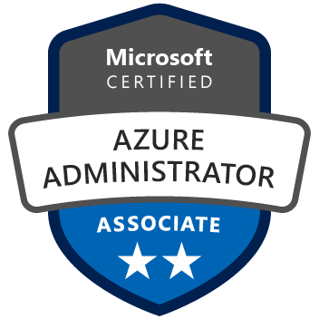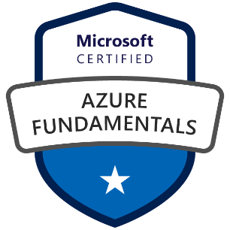 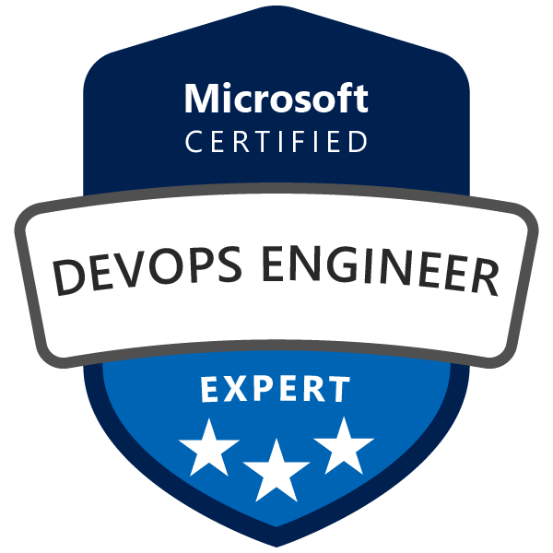

**Y V SubbaRao**

**Devops Engineer**

**Phone: +1 (346) 946 4179**

**Email:** [**yarramsettivsr@gmail.com**](yarramsettivsr@gmail.com)

**LinkedIn:** [**http://linkedin.com/in/y-v-subbarao-960b17280**](http://linkedin.com/in/y-v-subbarao-960b17280)

**SUMMARY:**

* Result-oriented IT Professional with 11 years of experience in developing the skills to increase velocity, reliability, and quality with high focus on security, scaling new heights of success and leaving a mark of excellence in DevOps, Microservices& Cloud Engineering.
* A Visionary leader with specialization in Digital Cloud Transformation Roadmaps to gain insights and capitalize, Cloud Native Architectures, experience, and insight to elevate any application, computing platform infrastructure to Cloud.
* Demonstrated experience in transforming IT infrastructure and moving an organization toward a mature cloud-based (AWS/Azure) service delivery model.
* Experience in writing Infrastructure as a code (IaC) in Terraform. Created reusable Terraform modules in Azure environment.
* Possess deep experience in the design and implementation of fully automated Continuous Integration, Continuous Delivery, Continuous Deployment (CI/CD) pipelines and DevOps processes for agile projects using Harness, Jenkins and Azure DevOps.
* Experienced in productivity & efficiency enhancing tools implementation, administration & management in areas covering Static Analysis, Requirements Management, Defect Tracking, Quality Code Coverage and Code Reviews
* Expertise in implementing, configuring, securing, Load balancing, and administrating scalable cloud environments.
* Impressive success in planning, build, configuration, release, and deployment of applications across DEV, UAT, Pre-Production & Production environments.
* Acted as Subject Matter Expert in AWS/Azure Public cloud, including professional experience in architecting and operating solutions built on AWS/Azure.
* Hands on with Azure services but not limited to IaaS/PaaS Virtual Networks, VPN Gateway, Virtual Machines, Resource Groups, VPN, Azure Storage, Azure DB services, Azure Functions, Azure Key vault, Azure App Service, Azure Load Balancing, Application Gateways, Auto-Scaling, AKS, Azure Container Service (ACS), Azure Container Registry, Azure DNS, Azure Monitor.
* Hands on experience in working with Azure container service for deploying the containers.
* Proficiency in using Docker Hub, Docker Engine, Docker images, Docker Weave, Docker Compose, Docker Swarm, and Docker Registry.
* Good working experience with build tools like maven and Gradle.
* Setting up the build, configuration and auto deploying using maven/Gradle build tool.
* Hands on experience with Docker Hub, Azure Container Registry and Google artifactory.
* Extensive experience in installing, configuring, and administering Jenkins CI tool on Linux machines and used Jenkins Pipelines to drive all Microservices builds out to the Docker Registry and then deployed to Kubernetes.
* Hands on with installing and upgrading k8s clusters, implementing auto-scaling for the Kubernetes environment by using horizontal pod autoscaling (HPA) and VPA
* Extensively worked with Kubernetes objects but not limited to Deployments, Services, Volumes, ingress, ConfigMaps, Secrets.
* Proficient in using Kubernetes for container orchestration on managed Kubernetes services such as AWS EKS and Azure AKS.
* Expertise in configuring the monitoring and alerting tools according to the requirements like Prometheus and Grafana, setting up alerts and deployed multiple dashboards for individual applications in Kubernetes.
* Good experience with Helm charts deployments, writing manifest files to deploy k8s objects/micro services.

**Skills:**

|  |  |
| --- | --- |
| Cloud | AWS/AZURE |
| Database | Oracle, MySQL, AWS RDS, Dynamo DB, Kafaka |
| ERP | Oracle EBS 11i & R12 |
| CI/CD | Harness, Jenkins/Azure DevOps |
| Version Controls | Git, SVN, GitLab, GitHub, GitActions, Bitbucket, Azure Repos |
| Application Servers | Apache Tomcat, Jboss, Nginx |
| IAC | Terraform |
| Config Management | Ansible, Ansible Tower, Run deck, Puppet, Chef. |
| Containerization | Docker |
| Orchestration | Kubernetes, EKS, AKS, GKE. |
| DevOps Tools | Maven, Gradle, MS Build, NuGet, SonarQube, JFrog, GitOps (Argo CD), Helm |
| Monitoring | Dynatrace, CloudWatch, ELK, Prometheus, Grafana, Azure Monitor |
| Operating Systems | Windows, Linux |
| Scripting | Shell Scripting, Python, Groovy, HCL, YAML |

**Employment History and Work Experience**

**Client: Vertex** **Mar 2023 – Present**

**Role: Devops Engineer**

**Location: Boston (Remote)**

**Responsibilities:**

* Creating clusters using Kubernetes and worked on creating many pods, replication controllers, deployments, labels, health checks and ingress by writing YAML files.
* Application monitoring configurations – setting up the Kibana, Logstash, Prometheus, Grafana,
* Deploying AKS and Docker applications to Azure.
* Resolving issues using Azure Monitor, Log Analytics workspace and K8 logs
* Coordinating with different teams for VNET creation and connecting to DCS Hub.
* Creating respective Subnets, NSG, Routing tables, ILB ASE, App Service Plan, and Web APPS & API APPS Creation.
* Used maven to build the project and deploy the application on the server.
* Used maven and Gradle for build framework and Jenkins for continuous build system.
* Configuration of Key Vaults and automating the process of adding secrets to Azure KVs while deploying the application.
* Worked in container based technologies like docker, kubernetes and OpenShift.
* Managing the OpenShift cluster that include scaling upa and down the AWS app nodes.
* Created and attached managed identity to establish secure connectivity between two resources of Azure cloud environment.
* Configured and managed more than ten CI/CD pipelines to deploy different kinds of application running on JAVA, .Net using Harness, Jenkins and Azure DevOps.
* Configured and maintained Harness, Jenkins to implement CI/CD process and integrated with Maven and Gradle to schedule the builds and SonarQube to scan the vulnerabilities.
* Configured and maintained Harness CI/CD pipelines using declarative approach for each stage starting from build to the deployment.
* Instrumented Dynatrace with AWS EC2, Lambda applications.
* OpenShift virtualized paas provider useful in automating the provisioning of commodity computing resources for cost and performance efficiency.
* Experience in micro services development using spring boot and deployment in PCF.
* Installed PCF on instances to manage teh containers created by PCF.
* Having experience in collaborate and govern the Terraform configuration changes.
* Expertise on infrastructure code converge process have changes being made in an auditable and reproducible manner to generate artifacts could be tested, verified, and deployed as needed.
* Hands on experience isolation and packaging application components in distributed containers, horizontal scaling process of spinning up and down multiple instances of each component.
* Achieved Kubernetes cluster security by implementing RBAC’s, network policies and audit logging.
* Managed Kubernetes charts using Helm and created reproducible builds of the Kubernetes applications, managed Kubernetes manifest files & releases of Helm packages.
* Involved in developing the Terraform resources for the required use cases.
* Involved in creating the interpolation environment using Terraform console for basic testing and debugging and in resolving the issues related to Terraform deployment, Terraform orchestration.
* Involved in working with team resolving issues like Terraform shared storage state files.
* Involved in creating and managing the for shared storage state files with the support of S3.

**Key Skills:** Amazon AWS, Git, Jenkins, Microsoft Azure, Azur Key vault, Azure DevOps, Terraform, Ansible, Dockers, Kubernetes, Helm, Argo CD, Python, ELK, Prometheus, Grafana, Data dog, ServiceNow.

**Client: Tech Mahindra / AT&T Sep 2021 to Feb 2023**

**Role: Devops Engineer**

**Location:** **Katy, Texas**

**Responsibilities:**

* Managed projects as necessary while leading the team, along with code deployments, fixes, updates and related processes.
* Coordinated with architects and engineers of other areas to design networks, systems, storage environment that effectively reflect business needs, security requirements, and service level requirements.
* Provisioned and managed different cloud services of Azure based on the customer requirements.
* Managed GIT Configuration, Branching and Merging, resolved conflicts, Push changes, etc.
* Integrated GIT into Jenkins to automate the code check-out process and continuous integration system.
* Configured web hooks in Bit bucket to trigger automated builds in Jenkins.
* Good understanding of pivotal cloud foundry (PCF) architecture, PCF components and their functionalities. Experienced in using pivotal cloud foundry CLI for deploying application and other CF management activities.
* Used Maven and Gradle scripts for building and deploying the application in web/app servers.
* Understanding of cloud environment like AWS,Azure,PFC.
* Used Azure container service (ACS) to deploy and manage containers using popular container orchestration systems such as Kubernetes and Docker Swarm.
* Instrumented Dynatrace with micro services and Docker.
* Good Knowledge on Materialized Views, Creating Sequences and Dynamic SQL.
* Setting up the build and deployment automation for java base project by using Jenkins and Maven.
* Develop and implement an automated infrastructure using puppet, wrote puppet models for installing and managing java versions, wrote a python plugin for collected to write metrics to state.
* Established infrastructure service monitoring using Prometheus and Grafana.
* Extensively used Azure Key vault in the Azure ecosystem for securing and managing sensitive data, and to comply with industry-specific regulations and standards.
* Used PowerShell not limited to creating key vault, add and remove a secret from the key vault, encrypt and decrypt the data using key vault.
* Implemented custom RBAC roles, Resource Group polices based on customer requirements to manage the user access.
* Created Jenkins CICD pipelines for continuous build and deployment and integrated Junit and SonarQube plugins in Jenkins for automated testing and for code quality check.
* Configured Azure DevOps Pipelines for Pushing NuGet Dependencies into JFrog antifactory and later utilize them in various applications.
* Installed build agents on build servers and configured agent queue, agent pools on Azure DevOps server to support Build and release pipelines.
* Integrated code scan tools like SonarQube, fortify code Analyzer on Azure DevOps Build server and integrate the scan tasks in the build pipeline to resolve code vulnerabilities.
* Written reusable templates using Terraform to build staging and production environments on Azure.
* Provisioned Kubernetes clusters using Azure virtual machines using Terraform.
* Provisioned managed Kubernetes clusters like EKS and AKS by using Terraform.
* Used Kubernetes to orchestrate the deployment, scaling, and management of Docker Containers.
* Troubleshooted different kinds of Kubernetes pod issues.
* Worked with different resources of Kubernetes such as Deployments, Replica sets, volumes, resource limits, ConfigMaps Secrets, Certificates to effectively manage the micro services environments.
* Worked with Kubernetes networking through services like NodePort, Cluster IP and Load Balancer.
* Achieved Kubernetes cluster security by implementing RBAC’s, network policies and audit logging.
* Managed Kubernetes charts using Helm and created reproducible builds of the Kubernetes applications, managed Kubernetes manifest files & releases of Helm packages.
* Experienced in creating pods and clusters using templates in Kubernetes and deploying using Helm chart.
* Managed Kubernetes charts using helm and created reproducible builds of Kubernetes applications.
* Setup GitOps operator using Argo CD for automatic deployment of microservices applications to a Kubernetes cluster.
* Created automation solutions to instance Splunk environments using Kubernetes and cloud computing.
* Experienced with Agile-Scrum methodologies, effectively involved in sprint backlog refinement, meetings to smooth user stories flow.
* Coordinated with product owner, scrum master to refine the backlog and understand the project requirement.

**Key Skills:** Amazon AWS, Git, GitActions, Jenkins, Microsoft Azure, Azur Key vault, Azure DevOps, Terraform, Ansible, Dockers, Kubernetes, Helm, Argo CD, Python, Java, ELK, Prometheus, Grafana, Data dog, ServiceNow.

**Client: Wipro / ICICI BANK** **Dec 2016 to Sep 2021**

**Role: Cloud Engineer**

**Location: Hyderabad**

**Responsibilities:**

* Involved in deploying applications utilizing AWS stack (Including EC2, VPC, Transit Gateway, VPN Peering, Site-to-Site VPN, Route53, S3, RDS, Elastic search,CloudFront, Config, Glacier, Elastic ache, IAM, focusing on high-availability, fault tolerance, and auto-scaling and CloudWatch.
* Configured Aws lambda function to reduce Amazon Elastic Compute Cloud (Amazon EC2) usage by stopping and starting instances at predefined times.
* Worked with many Azure cloud services based on the customer requirements.
* Administrating Azure services and monitoring the health of the environment.
* Creating and configuring Azure virtual network and network peering.
* Designed and configured Azure Virtual Networks, Subnets, Vnet Peering, DNS settings and Security policies.
* Used JMS (Java Messaging service) for asynchronous communication between different modules.
* Extensively used java collection framework and exception handling.
* Used AWS and Azure to create cloud based Splunk Kubernetes clusters.
* Creating, configuring, and managing GIT and GIT repositories in windows and Linux environments.
* Coordinated with developers to establish and apply appropriate branching, labelling/naming conventions using GIT source control and analyzed and resolved conflicts related to merging of source code for GIT.
* Provisioning AWS cloud infrastructure using Terraform and configuring them using Ansible.
* Infrastructure Patch management for all UNIX servers using Ansible.
* Worked with container-based deployments using Docker, working with Docker images, Docker Hub and Docker-registries and Kubernetes.
* Developing and maintaining the continuous integration and deployment pipelines using Jenkins, Git, Maven, JFrog, and Ansible.
* Written the Ansible YAML scripts to configure the remote servers.
* Used ansible tower to schedule some database daily activities and weekly activities like patching and restarting the databases running on RedHat Linux servers.
* Configured and maintained Jenkins CI/CD pipelines using declarative approach for each stage starting from build to the deployment.
* Used Azure DevOps services such as Azure Repos, Azure Pipelines and Azure Boards to plan work and collaborate on code development, built and deployed applications.
* Experience in automation of manual tasks & processes enabling better governance and compliance using Python.

**Key Skills:** Amazon AWS, Microsoft Azure, Azure Devops, Git, Jenkins, Azure DevOps, Terraform, Ansible, Dockers, Kubernetes, Kibana, Prometheus, Python, Java, Grafana, ServiceNow

**Client: W3 Technologies / Dr. Reddy’s Pvt. Ltd Dec 2012 to Nov 2016**

**Role: Software Engineer**

**Location: Hyderabad**

**Responsibilities:**

* Worked on SQL*Loader to load data from flat files obtained from various clients into Oracle database tables.
* Developed and modified triggers, packages, functions and stored procedures for data Conversions and PL/SQL procedures to create database objects dynamically based on user inputs.
* Created new and updated existing Procedures, Functions, Packages and Cursors for running different reports as needed by business users
* Involved in creating new database objects such as Tables, Indexes, Views and Synonyms.
* Handled errors using exception handling for debugging and displaying error messages in the application.
* Wrote SQL Queries using Joins, Sub Queries and correlated sub-Queries to retrieve data from the database.
* Perform DML, DDL Operations as per the Business requirement.
* Requirement gathering and working according to the CR.
* Experience in Data migration using import and export.
* Good Knowledge on Materialized Views, Creating Sequences and Dynamic SQL.
* Worked with Informatica Power Center v 9.0.1 and 9.5.1 with its core components Source Analyzer, Data warehousing Designer, Mapping & Mapplet Designer and Transformation Designer.
* Design and Developed Informatica mappings, defined workflows and tasks, monitored sessions, exported and imported mappings and workflows to populate the tables in Data Warehouse (DW) as per business rules.
* Involved in Data Validating, Data integrity, Performance related to DB, Filed Size Validations, Check Constraints and Data Manipulation and Updates by using SQL Single Row Functions. Unix/Linux.
* Worked on the awk, sed, chmod, scp, rename/remove of a file.
* Working in Oracle Web Logic, Internet Information Services (IIS), IBM WAS, MS SQL, and Oracle database, Microsoft office (Word, Excel, Outlook, and PowerPoint).
* Generating Reports from the Oracle Database.
* Providing oracle and UNIX production support to major’s applications.
* Involved Explain plan and investigate the performance issues.
* Built the Data Model in SFDC using Standard objects, Custom Objects, Custom Fields and Relationships.
* Database schema password change activity as per audit policies.
* Responsible for providing the support in L1/L2 level depending on the Priority of the issues to meet client SLA.

**Environment:** Oracle 10g, Unix, PL/SQL Developer, SQL, Oracle WebLogic, MS SQL, Internet Information Services (IIS), ARCOS, Service Manager (ITSM) and Service desk ticket tools, Putty, SFTP, AppDynamics / OEM, monitoring tool, Control-M, Autosys and Crontab.

**Education:**

* Bachelors in Information Technology, JNTUH, Hyderabad in 2012.